WEB BROWSER

A **Web browser** is a software application which enables a user to display and interact with text, images, videos, music, games and other information typically located on a Web page at a Web site on the **World Wide Web** or a local area network. Text and images on a Web page can contain hyperlinks to other Web pages at the same or different Web site. Web browsers allow a user to quickly and easily access information provided on many Web pages at many Web sites by traversing these links. Web browsers format HTML information for display, so the appearance of a Web page may differ between browsers.

**History**

The history of the Web browser dates back to late 1980s, when a variety of technologies laid the foundation for the first Web browser, the **WorldWideWeb**, by **Tim Berners-Lee** in 1991. That browser brought together a variety of existing and new software and hardware technologies.

The introduction of the NCSA **Mosaic Web browser in 1993** – one of the first graphical web browsers – led to an explosion in Web use. Marc Andreessen, the leader of the Mosaic team at NCSA, soon started his own company, named Netscape, and released the Mosaic-influenced **Netscape Navigator in 1994**, which quickly became the world's most popular browser, accounting for 90% of all Web use at its peak.

Microsoft responded with its browser **Internet Explorer in 1995** (also heavily influenced by Mosaic), initiating the industry's first browser war. By bundling Internet Explorer with Windows, Microsoft was able to leverage its dominance in the operating system market to take over the Web browser market; Internet Explorer usage share peaked at over 95% by 2002.

In 1998, Netscape launched what was to become the Mozilla Foundation in an attempt to produce a competitive browser using the open source software model. That browser would eventually evolve into **Firefox**, which developed a respectable following while still in the beta stage of development; shortly after the release of Firefox 1.0 in late 2004, Firefox (all versions) accounted for 7.4% of browser use. As of February 2009, Firefox has a 21.77% usage share.

**Opera** debuted in 1996; although it has never achieved widespread use, having less than 1% browser usage share as of February 2009, it has a substantial share of the fast-growing mobile phone Web browser market, being preinstalled on over 40 million phones. It is also available on several other embedded systems, including the Nintendo Wii.

**Apple's Safari** had its first beta release in January 2003; as of February 2009, it has a dominant share of Apple-based Web browsing, accounting for just over 8% of the entire browser market. The most recent major entrant to the browser market is **Google's Chrome**, first released in September 2008. As of February 2009, it has a 1.15% usage share.

**Browser Window Terminology**

* **Title Bar** : The location where the document’s title is displayed.
* **Menu Bar** : The place showing the headings of the main pull-down command menus.
* **Toolbar** : The area providing access to a number of single-mouse-clock commands.

**Figure 1 : Sample Browser Window**

* 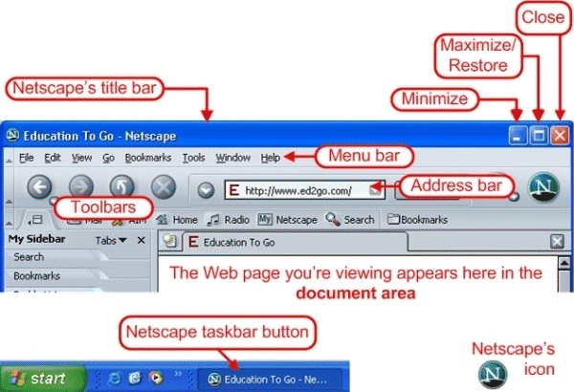**Location** : The area where the URL (Uniform Resource Locator) of the document is displayed. The item in the location field may begin with http://, file://, https://, ftp://, gopher://, news:, mailto:, telnet://, or javascript://.
* **Hot Buttons** : Single- click buttons that provide a number of convenient features.
* **Netscape Icon** : An image that shows movement to indicate when a document is being downloaded from the Internet.
* **Scroll Bar** : Arrows that allow the user to display a different part of a ‘large’ document.
* **Document Area** : The part of the window that is used for displaying the currently loaded document.
* **Status Bar** : A field used to convey helpful information to the user, such as a URL or a programmer-specified message.
* **In-line Image** : An image appearing within a document.
* **Hyperlink** : A highlighted part of a document that, when selected, causes the browser to retrieve and display a new document.

**Protocols and Standards**

Web browsers communicate with Web servers primarily using Hypertext Transfer Protocol (HTTP) to fetch Web pages. HTTP allows Web browsers to submit information to Web servers as well as fetch Web pages from them. The most-commonly-used version of HTTP is HTTP/1.1. HTTP/1.1 has its own required standards that Internet Explorer does not fully support, but most other current-generation Web browsers do.

Pages are located by means of a URL (Uniform Resource Locator), which is treated as an address, beginning with *http:* for HTTP transmission. Many browsers also support a variety of other URL types and their corresponding protocols, such as *gopher:* for Gopher (a hierarchical hyperlinking protocol), *ftp:* for File Transfer Protocol (FTP), *rtsp:* for Real-time Streaming Protocol (RTSP), and *https:* for HTTPS (HTTP Secure, which is HTTP augmented by Secure Sockets Layer or Transport Layer Security).

The file format for a Web page is usually HTML (HyperText Markup Language) and is identified in the HTTP protocol using a MIME *content type*. Most browsers natively support a variety of formats in addition to HTML, such as the JPEG, PNG and GIF image formats, and can be extended to support more through the use of plugins. The combination of HTTP *content type* and URL protocol specification allows Web-page designers to embed images, animations, video, sound, and streaming media into a Web page, or to make them accessible through the Web page.

Early Web browsers supported only a very simple version of HTML. The rapid development of proprietary Web browsers led to the development of non-standard dialects of HTML, leading to problems with Web interoperability. Modern Web browsers support a combination of standards-based and *de facto* HTML and XHTML, which should be rendered in the same way by all browsers. No browser fully supports HTML 4.01, XHTML 1.x or CSS 2.1 yet. Many sites are designed using WYSIWYG HTML-generation programs such as Adobe Dreamweaver or Microsoft FrontPage. Microsoft FrontPage often generates non-standard HTML by default, hindering the work of the W3C in promulgating standards, specifically with XHTML and Cascading Style Sheets (CSS), which are used for page layout. Dreamweaver and other more modern Microsoft HTML development tools such as Microsoft Expression Web and Microsoft Visual Studio conform to the W3C standards.

Some of the more popular browsers include additional components to support Usenet news, Internet Relay Chat (IRC), and e-mail. Protocols supported may include Network News Transfer Protocol (NNTP), Simple Mail Transfer Protocol (SMTP), Internet Message Access Protocol (IMAP), and Post Office Protocol (POP). These browsers are often referred to as "Internet suites" or "application suites" rather than merely Web browsers.

**Personal Preferences**

Most browsers have a number of options that a user can set.

* **Cookies** : User can ask to be notified before a cookie is written, and can then decide whether or not to allow the cookie to be written.
* **Disk Cache** : User can set the size of cache. The cache stores the HTML source code and images of Web presentations visited.
* **Fonts** : User can select a font specification and also set a default font size.
* **Helper applications** : User can configure helper applications to handle certain types of data that the browser is unable to process.
* **Home page location** : User can specify the page that gets loaded when the browser is first launched.
* **Images** : User may specify whether or not images are loaded. Options for color selection are also available.
* **Java and JavaScript** : User can enable or disable these types of programs from running within the browser.
* **Messages** : User can specify a default signature file or a default carbon copy address for outgoing messages. This can be set for regular email or for posts to newsgroups.

**Bookmarks**

**Internet bookmarks** are stored Web page locations (URL’s) that can be retrieved. As a feature of all modern Internet web browsers, their primary purpose is to easily catalog and access web pages that a user has visited and chosen to save. Saved links are called "favorites" in Internet Explorer, and by virtue of the browser's large market share, the term *favorite* has been synonymous with *bookmark* since the early days of widely-distributed browsers. Bookmarks are normally visible in a browser menu and stored on the user's computer, and commonly a folder metaphor is be used for organization. In addition to bookmarking methods within most browsers, many external applications exist for bookmark management.

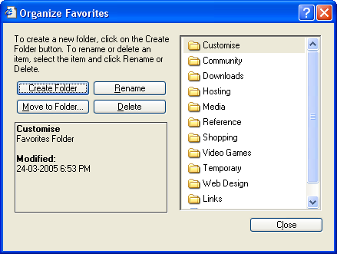Bookmarks have been incorporated in browsers since the Mosaic browser in 1993. Bookmark lists were called *Hotlists* in Mosaic and in previous versions of Opera; this term has faded from common use. Other early web browsers such as ViolaWWW and Cello also had bookmarking features.

**Figure 2 : Favorites Window in Internet Explorer**

Bookmarks are a fundamental feature of web browsers, but some users have expressed frustration with bookmark collections that become disorganized and have looked for other tools to help manage their links. These tools include browser synchronizers and desktop applications.

With the advent of social bookmarking, shared bookmarks have become a means for users sharing similar interests to pool web resources, or to store their bookmarks in such a way that they are not tied to one specific computer or browser. Web-based bookmarking services let users save bookmarks on a remote web server, accessible from anywhere.

Newer browsers have expanded the "bookmark" feature to include variations on the concept of saving links. Mozilla Firefox introduced live bookmarks in2004, which resemble standard bookmarks but contain a list of links to recent articles supplied by a news site or weblog, which is regularly updated via RSS feeds. Bookmarklets are small scripts stored as bookmarks that can be clicked to perform a function.

**Plug-ins and Helper Applications**

In computing, a **plug-in** (plugin, addin, add-in, addon, add-on, snap-in or snapin) consists of a computer program that interacts with a host application (a web browser or an email client , for example) to provide a certain, usually very specific, function "on demand". Applications support plugins for many reasons. Some of the main reasons include :

* to enable third-party developers to create capabilities to extend an application
* to support features yet unforeseen
* to reduce the size of an application
* to separate source code from an application because of incompatible software licenses.

Mechanism

The host application provides services which the plug-in can use, including a way for plug-ins to register themselves with the host application and a protocol for the exchange of data with plug-ins. Plug-ins depend on the services provided by the host application and do not usually work by themselves. Conversely, the host application operates independently of the plug-ins, making it possible for end-users to add and update plug-ins dynamically without needing to make changes to the host application.

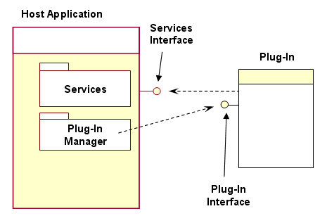Open application programming interfaces (APIs) provide a standard interface, allowing third parties to create plug-ins that interact with the host application. A stable API allows third-party plug-ins to continue to function as the original version changes and to extend the life-cycle of obsolete applications. The Adobe Photoshop and After Effects plug-in APIs have become a standard and competing applications have adopted them to some extent. Other examples of such APIs include Audio Units and VST.

**Figure 3 : Plug-In Framework**

Games and productivity applications often use plug-in architectures which allow original and third-party publishers to add functionality.

The Microsoft Flight Simulator series has become well-known for its aircraft add-ons. Outside software, a network switch may ship with an unoccupied but non-standard port to accommodate various optional physical-layer connectors.

Plug-ins and extensions

Plug-ins differ slightly from extensions, which modify or add to existing functionality. Plug-ins generally rely on the host application's user interface and have a well-defined boundary to their possible set of actions. Extensions have fewer restrictions on their actions, and may provide their own user-interfaces. Mozilla Firefox added support for extensions to help to decrease the size of the host application and to offer optional functions. Mozilla Firefox and related software products use the term "Add-on" as an inclusive category of augmentation modules that consists of plug-ins, themes, search engines and a well-developed system which aims to reduce the feature creep that plagued the Mozilla Application Suite.

A **helper application** is an external viewer program launched to display content retrieved using a web browser. Some common examples include Windows Media Player and QuickTime Player for playing streaming content.

Unlike a plugin(whose full code is included into browser code), a small line is added to the browser code to tell it to open a certain helper application in case it encounters a certain file format.

**Browser Wars**

The **browser wars** are competitions for dominance in the web browser marketplace. The term is used to denote two specific periods of time: the competition between market-dominating Netscape Navigator and its eventual defeat by Microsoft Internet Explorer during the late 1990s, and the competition from 2003 onwards between the dominating Internet Explorer and several other emerging browsers including Mozilla Firefox, Safari, Opera and, since mid-2008, Google Chrome.

Background

In the early 1990s, Tim Berners-Lee invented the World Wide Web, an Internet-based hypertext system which quickly became popular and defeated rivals including Hypercard and Gopher. Berners-Lee wrote the first web browser WorldWideWeb, later renamed Nexus to avoid confusion, and released it in 1991 for the NeXTstep platform.

By the end of 1992, many other browsers appeared, many of them based on the libwww library. These included many Unix browsers including Line-mode, ViolaWWW, Erwise and MidasWWW, as well as MacWWW (also known as Samba) for the Mac. This resulted in some choice among browsers and the first real competition among them, especially on Unix which now had several different graphical and text browsers available.

In 1993 more browsers were released - Cello, Arena, and Lynx also came out. The most notable of these, however, was the multiplatform Mosaic, developed at NCSA, would start to become the most popular. Mosaic's new features caught the attention of many. In the October 1994 Issue of *Wired*, Gary Wolf notes in the article, "The [Second Phase of the] Revolution Has Begun: Don't look now, but Prodigy, AOL, and CompuServe are all suddenly obsolete - and Mosaic is well on its way to becoming the world's standard interface."

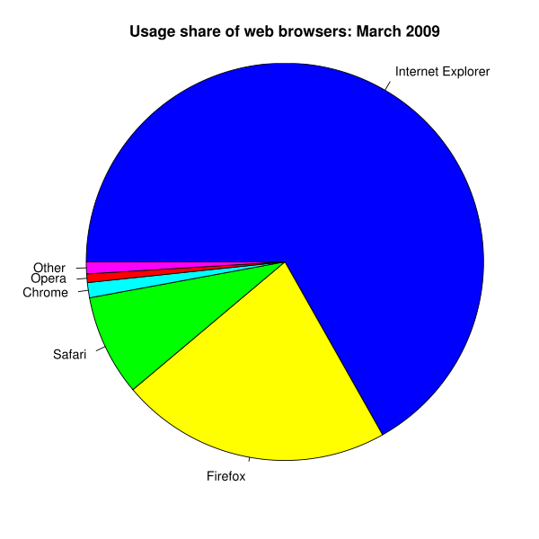Several companies licensed Mosaic to create their own commercial browsers, such as Spry Mosaic and Spyglass Mosaic. By 1994, Mosaic faced competition from its shells and new browsers including IBM Web Explorer, Navipress, SlipKnot (1.0), MacWeb, IBrowse, and most significantly Netscape Navigator.

One of the Mosaic developers, Marc Andreessen, founded the company Mosaic Communications Corporation and created a new web browser named Mosaic Netscape. To resolve legal issues with NCSA, the company was renamed Netscape Communications Corporation and the browser Netscape Navigator. The Netscape browser improved on Mosaic's usability and reliability - as well as boasting the then-impressive feature of being able to display pages as they loaded. By 1995, helped by the fact that the browser was free for non-commercial use, the browser dominated the emerging World Wide Web.

**Figure 4 : The usage share of web browsers.**

By 1994, Netscape faced some new competition from OmniWeb, WebRouser, and Microsoft's Internet Explorer 1.0, but continued to dominate. By 1996, the market had exploded with half a dozen new browsers as well as updates to older browsers, with Netscape releasing version 2.0 and 3.0 that year. Netscape was on top, but would soon be facing heavy competition from Internet Explorer in 1997.

**Submitted By :**

**Name : Rohit Aggarwal**

**Roll No. : 7CS-097**